**Artsthop Website**

Group 6 – Team members: Shafia, Joyce, Sai

**Description**: It is a personalized ecommerce website that is used by an artist to showcase and sell her work online. Selling art online not only enables the artist to reach larger audiences, but also enables them to have a connection with customers with real time feedback to improve business. It also enables the artist to probably make more money as well because a survey showed that online art sales reached almost [7.9 billion U.S. dollars in 2020](https://www.statista.com/statistics/284586/global-online-art-market-sales-2013/) which is predicted to only grow further. The target audience is art buyers, gallery owners, people trying to decorate their home/office or anyone looking for authentic art.

**Features:** Some of the features of this website include navigation Landing page, adding product from products page, providing information on the cart page, searching for orders using email address, login, sign-up.

**Pages and Components in the website:**

1. **Landing/Home page:** This is the home page where it displays the website name and description and also some of the featured art products. It also has information about the author as well as her social media handles in case you want to connect. It also displays some of the top art pieces along with their description. You can find these art pieces in the products list section. Landing page has been made with parallax effect which you can see as you scroll. See more button on top of the about section leads the user to the main galley for the products in store.

**Limitations:** We need to add links for the scrolling panel. We also need to add social media links for the social media icons, we can add that if we have actual media links for a real artist.

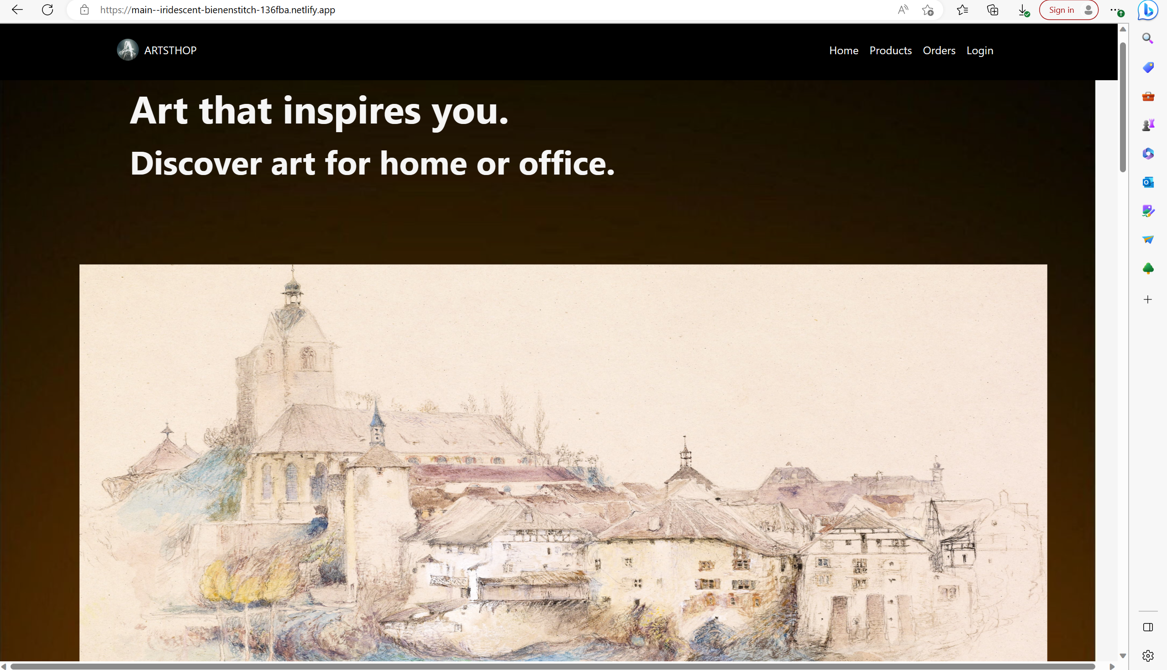

1. **Products page:** This page contains all of our art products that are available for sale along with the title, price and add to cart option. When the mouse is hovered, it shows a different perspective of the art piece either getting a close-up or zooming out effect. We have used cards to showcase the art in this page and we are retrieving the images from the database. This page also has a **cart** tab as well which is initially empty and displays a message saying you need to add products to the cart. Once the products are added then it displays the product with its description and the price, number of times the products have been added. Once the products have been added the cart automatically updates the price in the ‘total amount’ section each time. Once we have all the items in the cart we need to enter the details in the form and click on *google pay* button to allow us to pay. We can hit submit once the payment is done or without the payment as well for time being. The form evaluates and the email entered is stored in the database for future references. Once we enter our information and click on submit, it evaluates the form details and displays a thank you page with the order details and further information.

**Limitations:** The add and delete functionality is not working in the best way as we are unable to completely delete the product added (unless the page is refreshed) and the cart values when changed and navigated to products tab doesn’t take effect. We have also not tested the purchase with the google pay as we do not have test credit card data but we are able to login to our google account where it prompts us to login with our google account. As we have not fully implemented the payment, we can click on submit button without making the payment.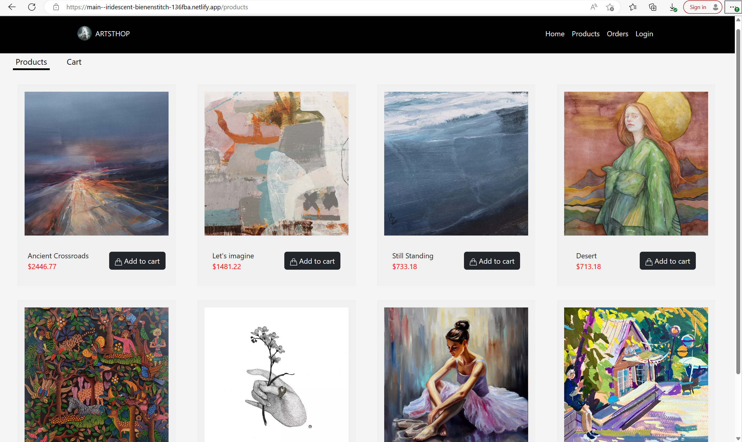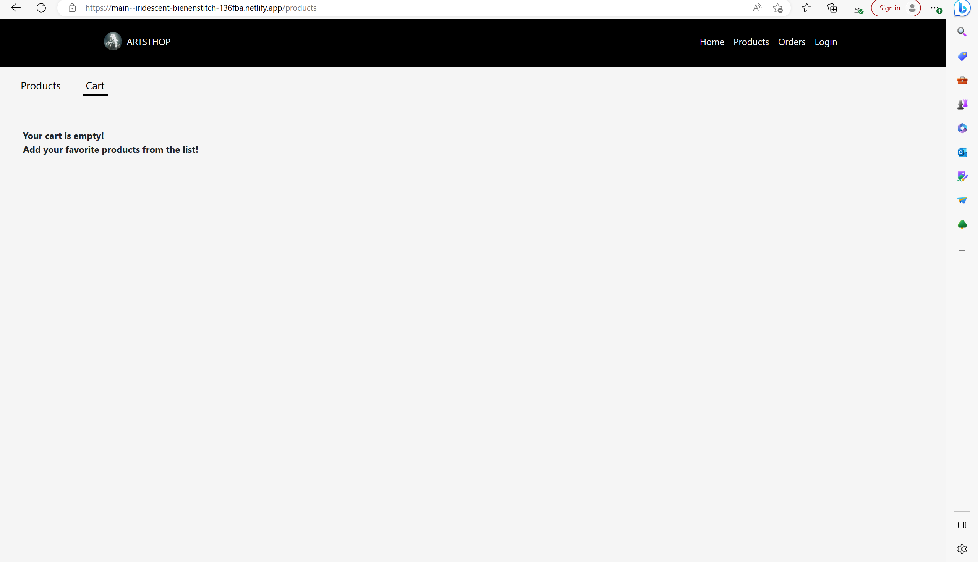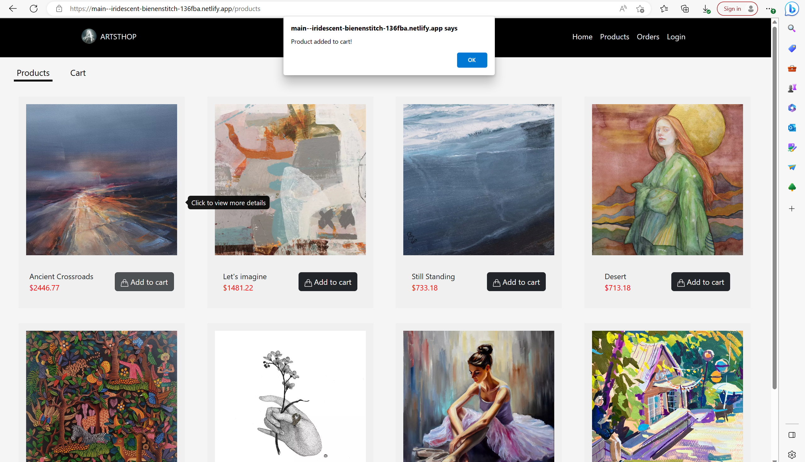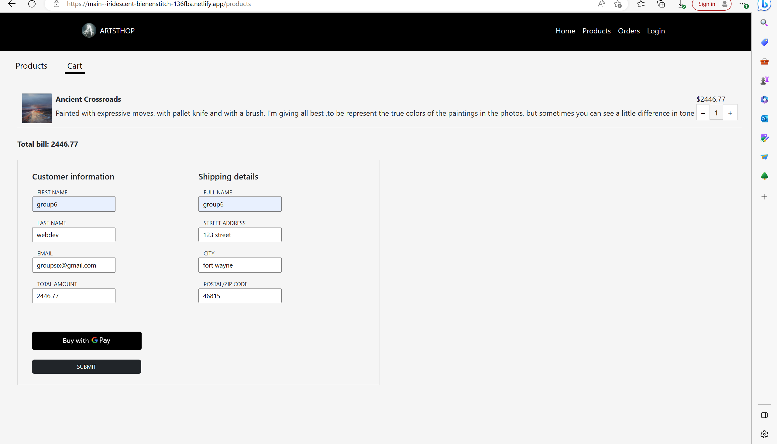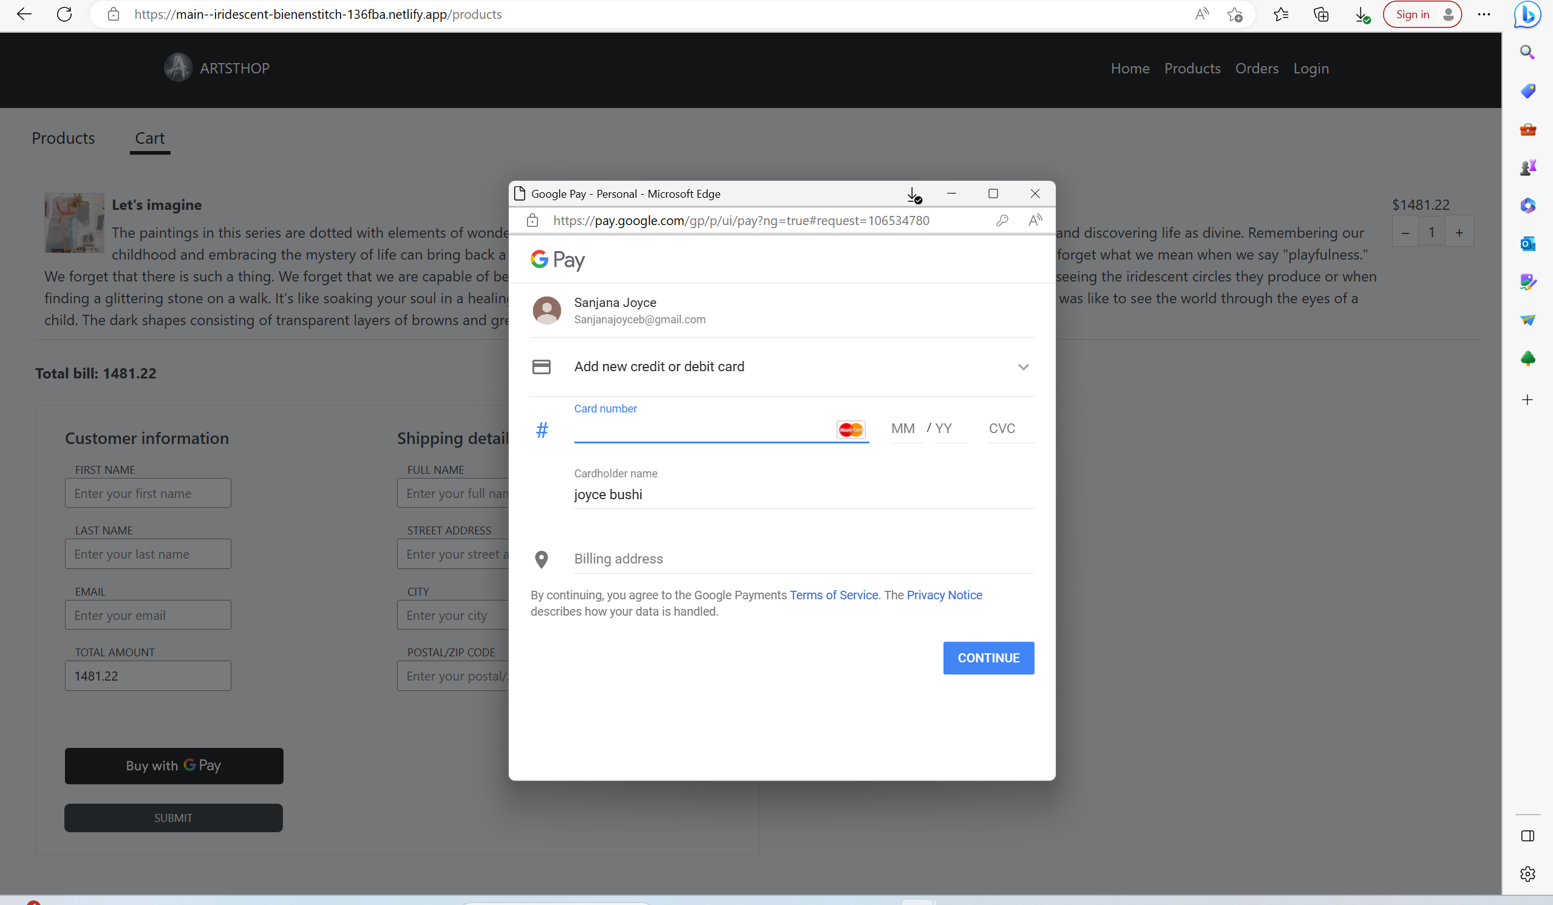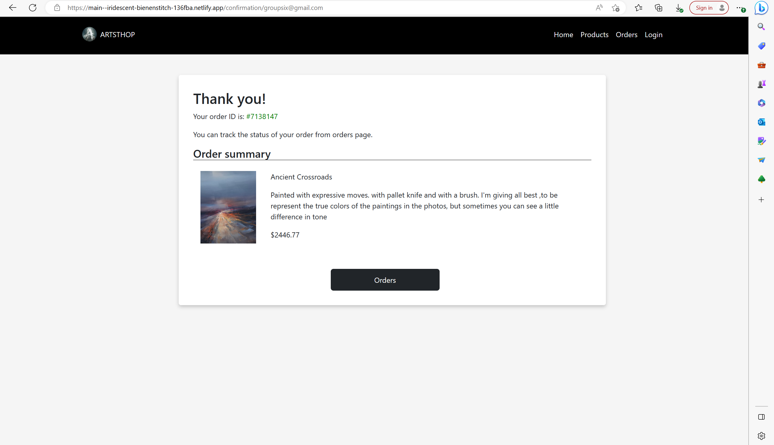

1. **View Page**: Once you click on any art product on the products page, it takes you to the view page for each product. It shows the magnified view of the products with the product description, materials used, dimensions of the product and images of the product in home or office environments so that the user gets an idea of what to expect. On the right-hand side tab it shows the title, price, and go back button which takes the user back to the products page. This page is good to get a detailed opinion on a particular product that catches the eye. 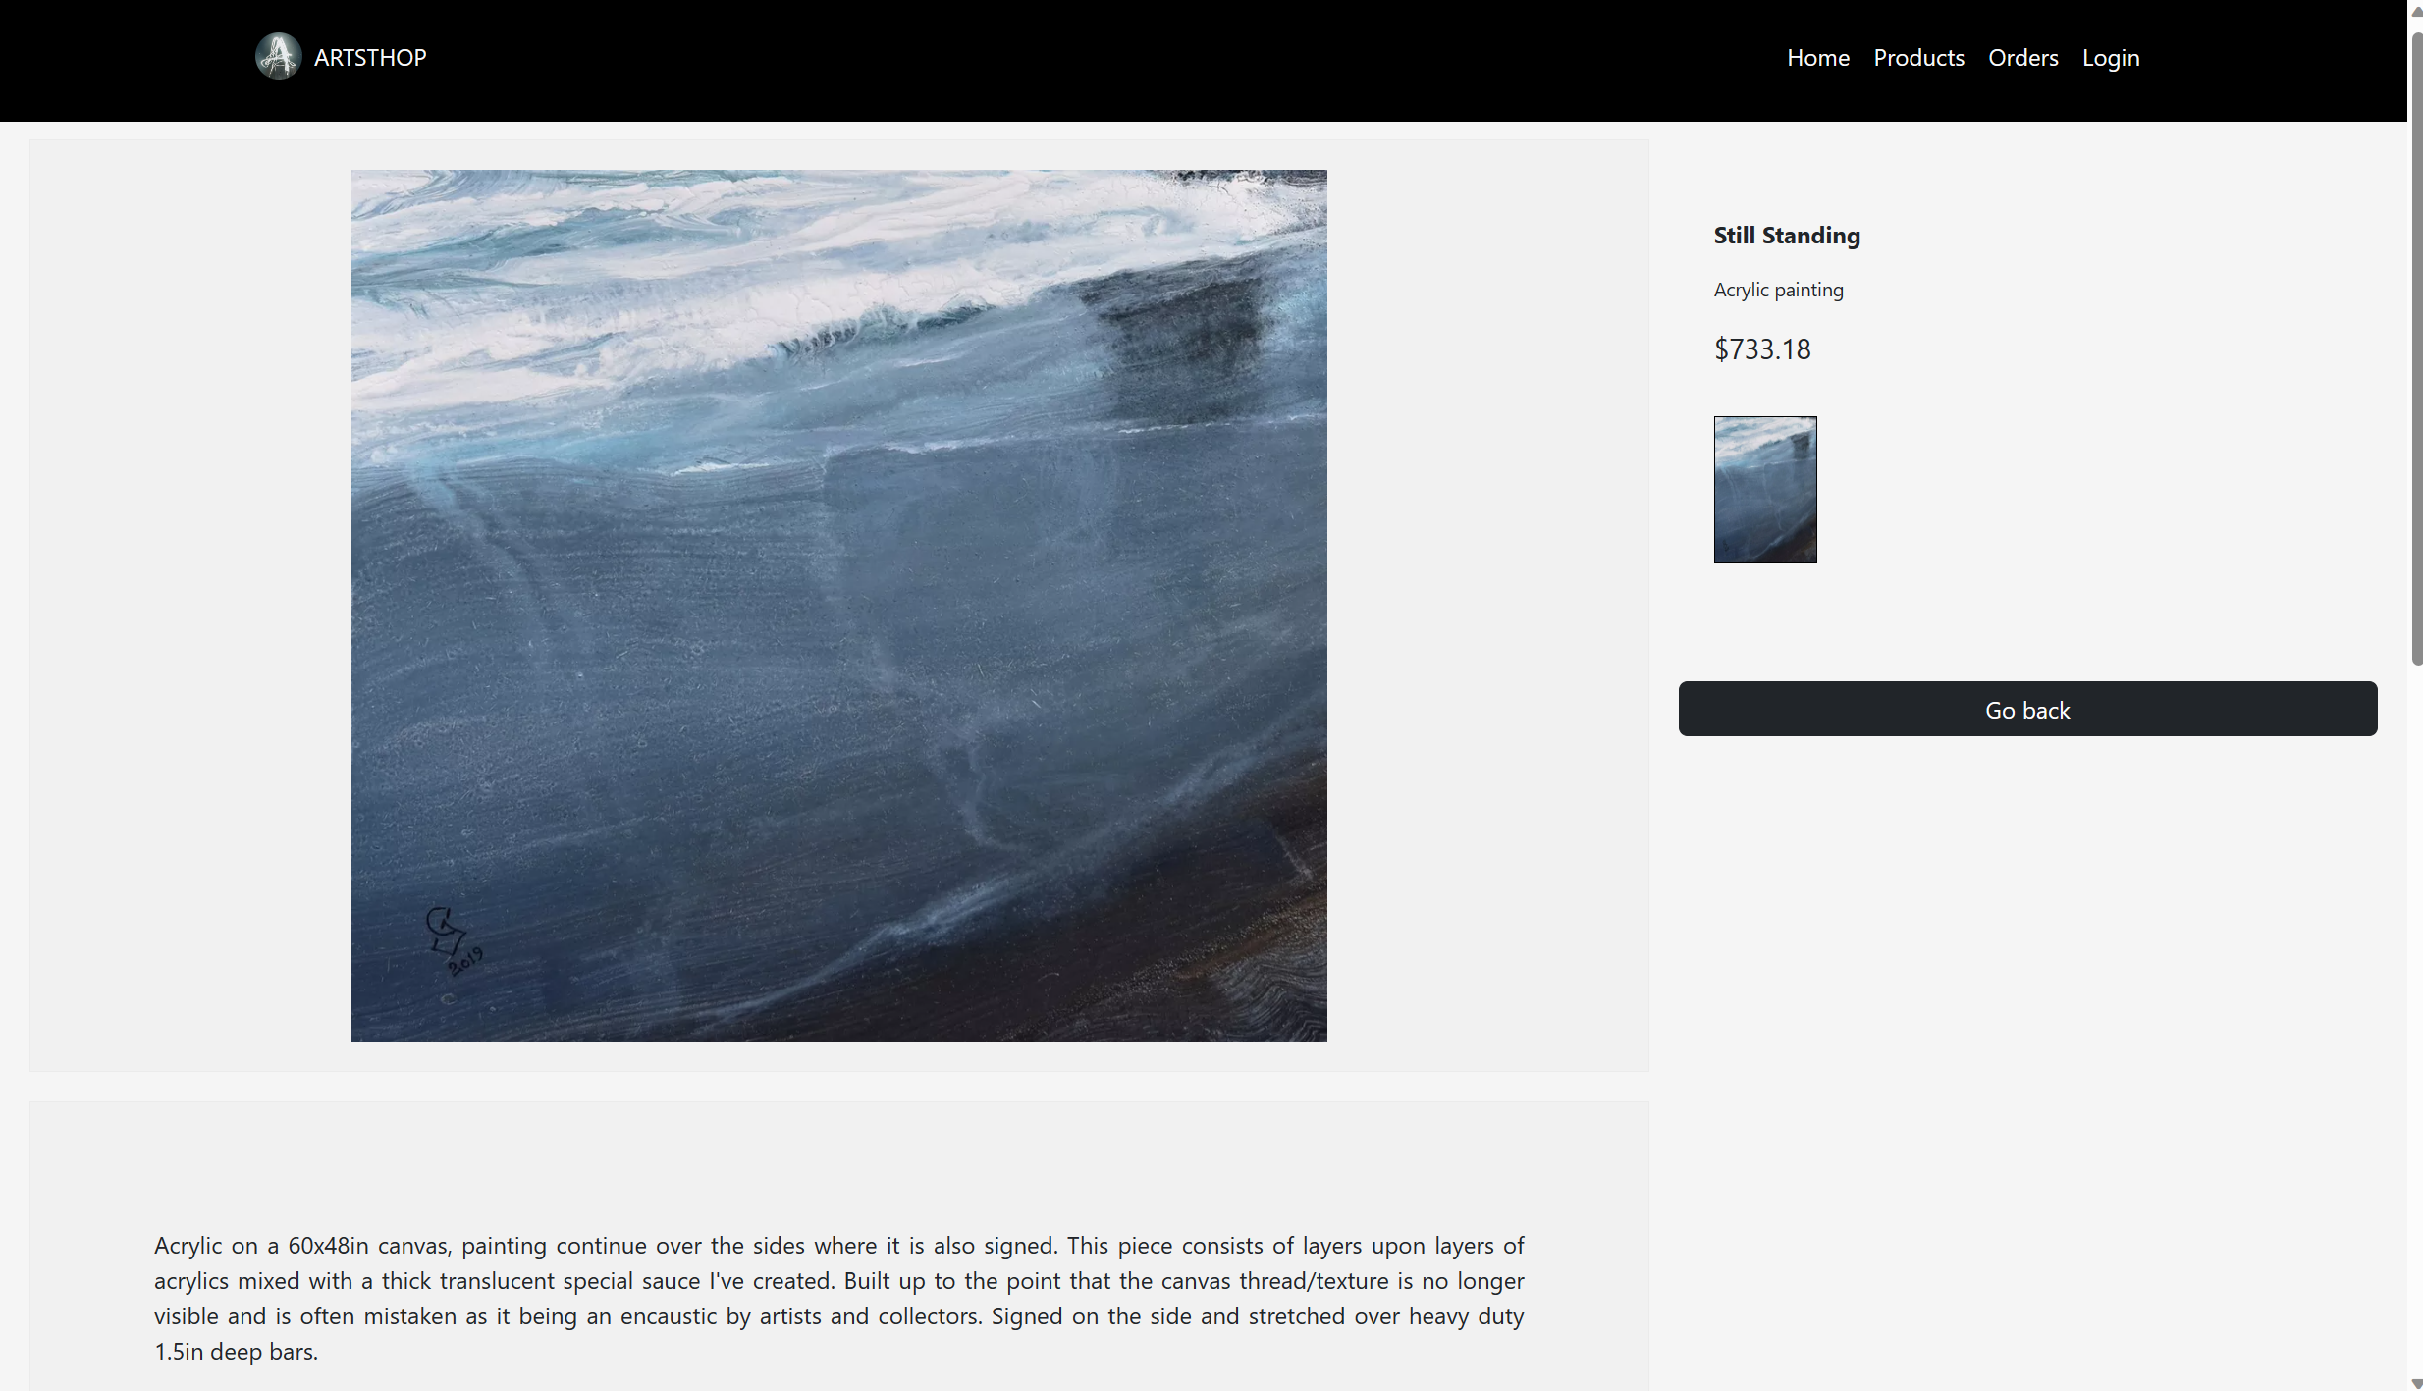
2. **Orders page:** After clicking on submit button, orders summary is displayed along with the orders button. When you click on the orders button it redirects you to the orders page where is has a search bar where the user can search for the orders, he placed using the email address with which he placed it. It retrieves the data from the database for that user email displaying the product, description as well as price.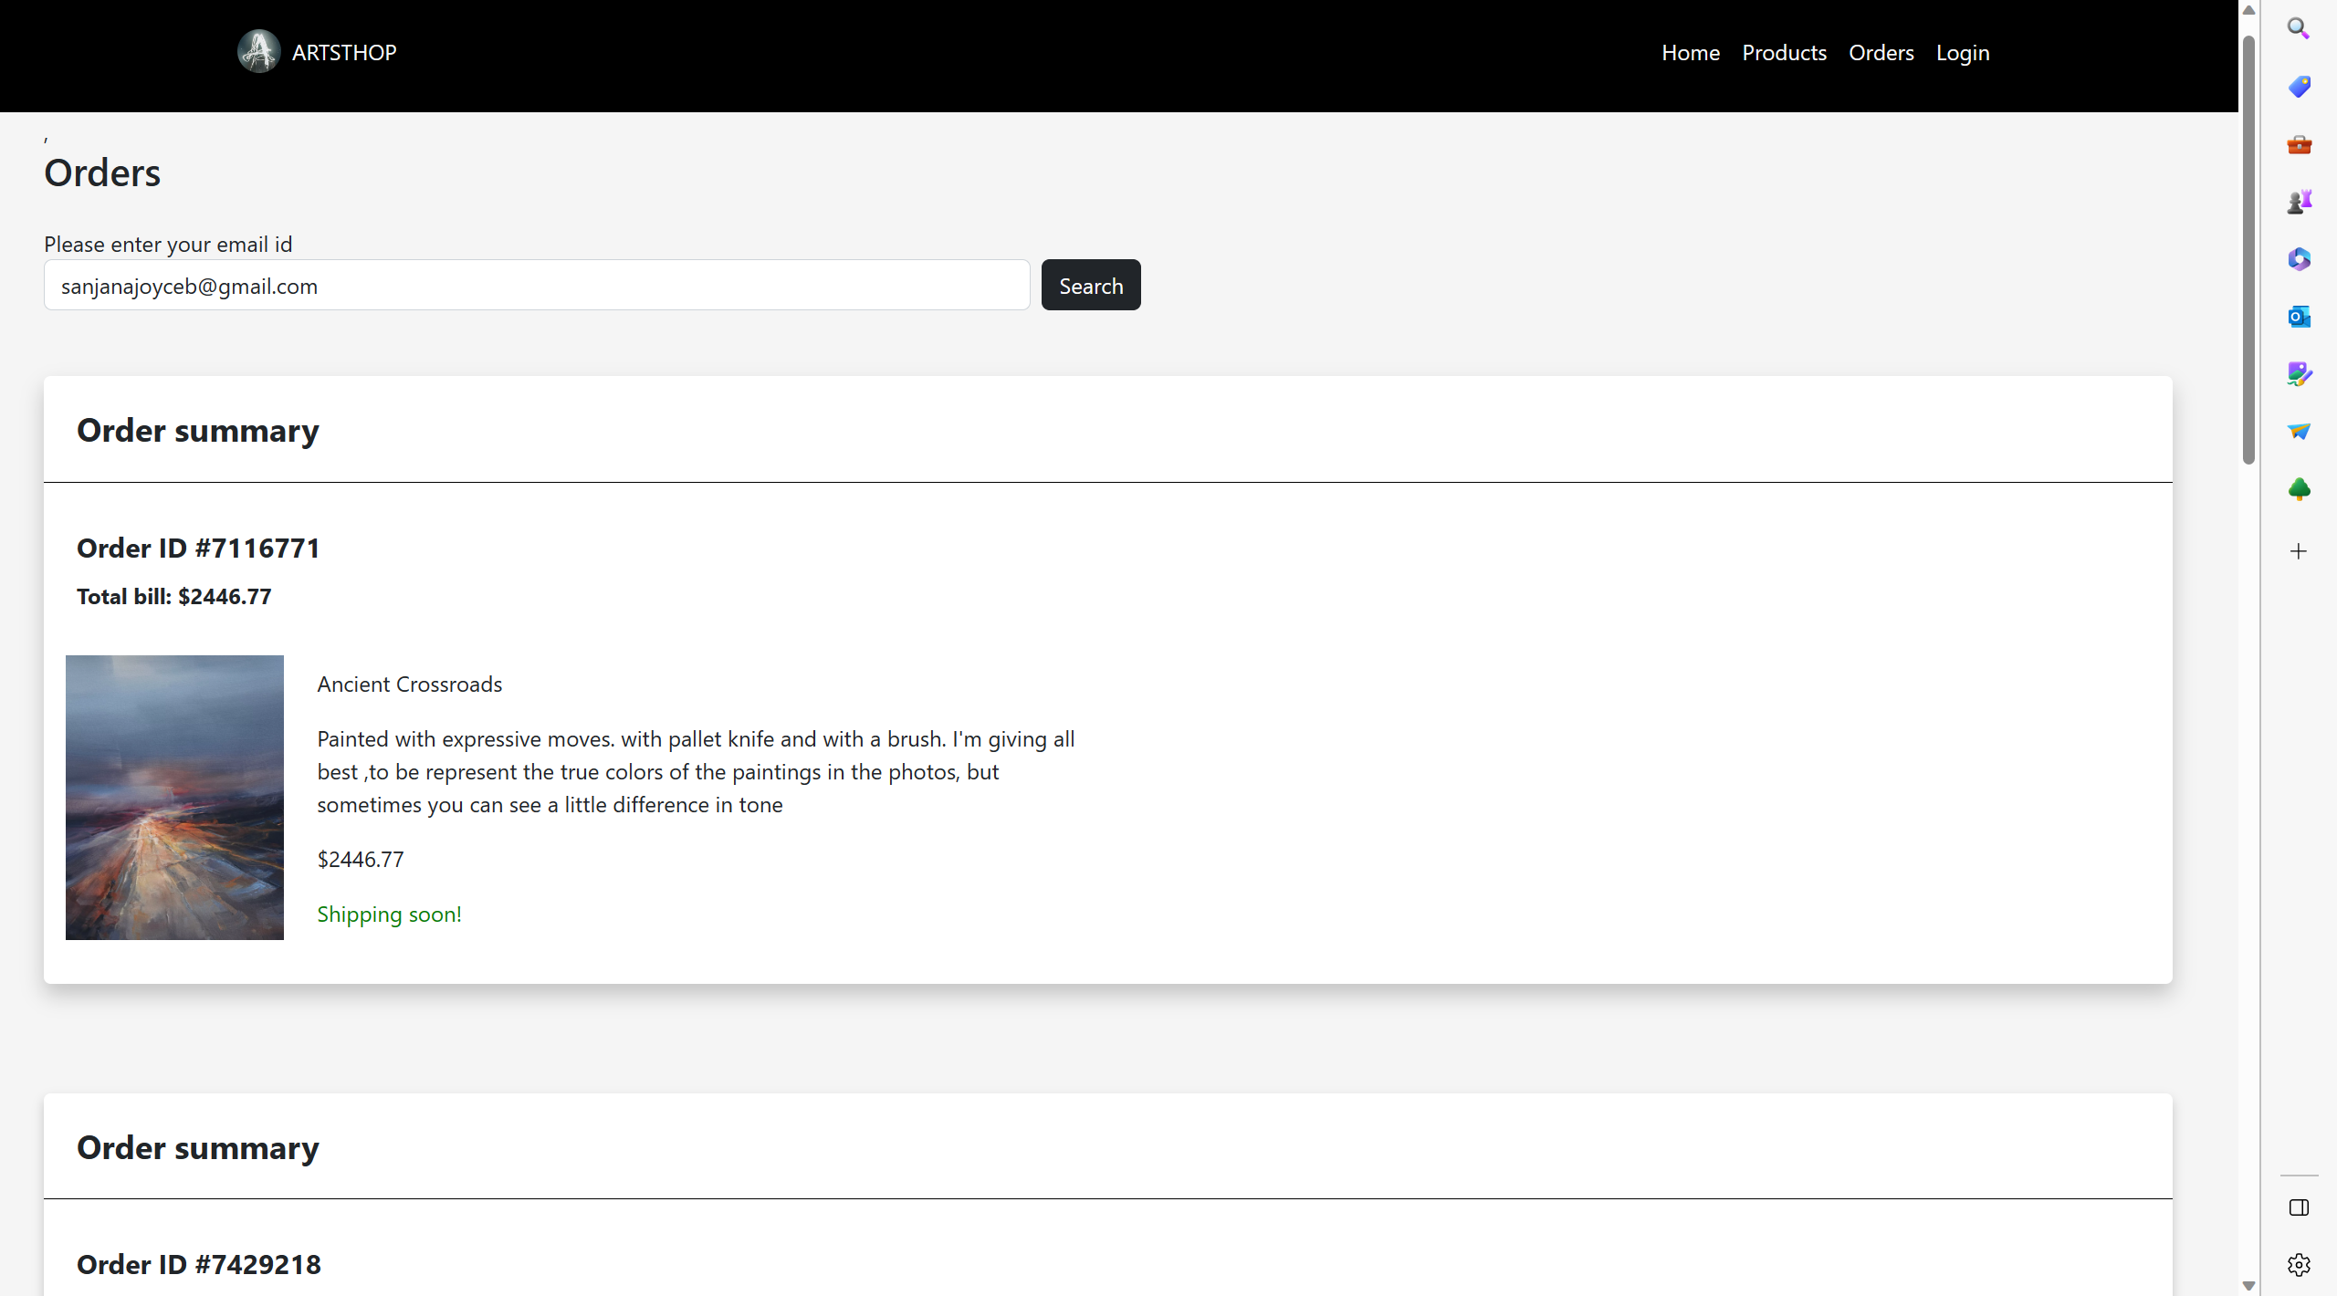
3. **Login page:** This page allows the user to login if he is already registered on the website or a new user can sign up with that option which is under the ‘sign in’ button on the page. If the user is not registered it throws an error when trying to login. When the user signs-up successfully it displays the success message. If a registered user signs-in it evaluates the entered data and redirects the user to the Landing page where the email address of the user is displayed on the right-hand corner. If we click on that it shows a drop-down menu which gives the options to view the user’s orders and also sign-out option. The orders option takes the user to his orders page and the sign-out button logs the user out.

**Limitations:** The forgot password functionality needs to be implemented.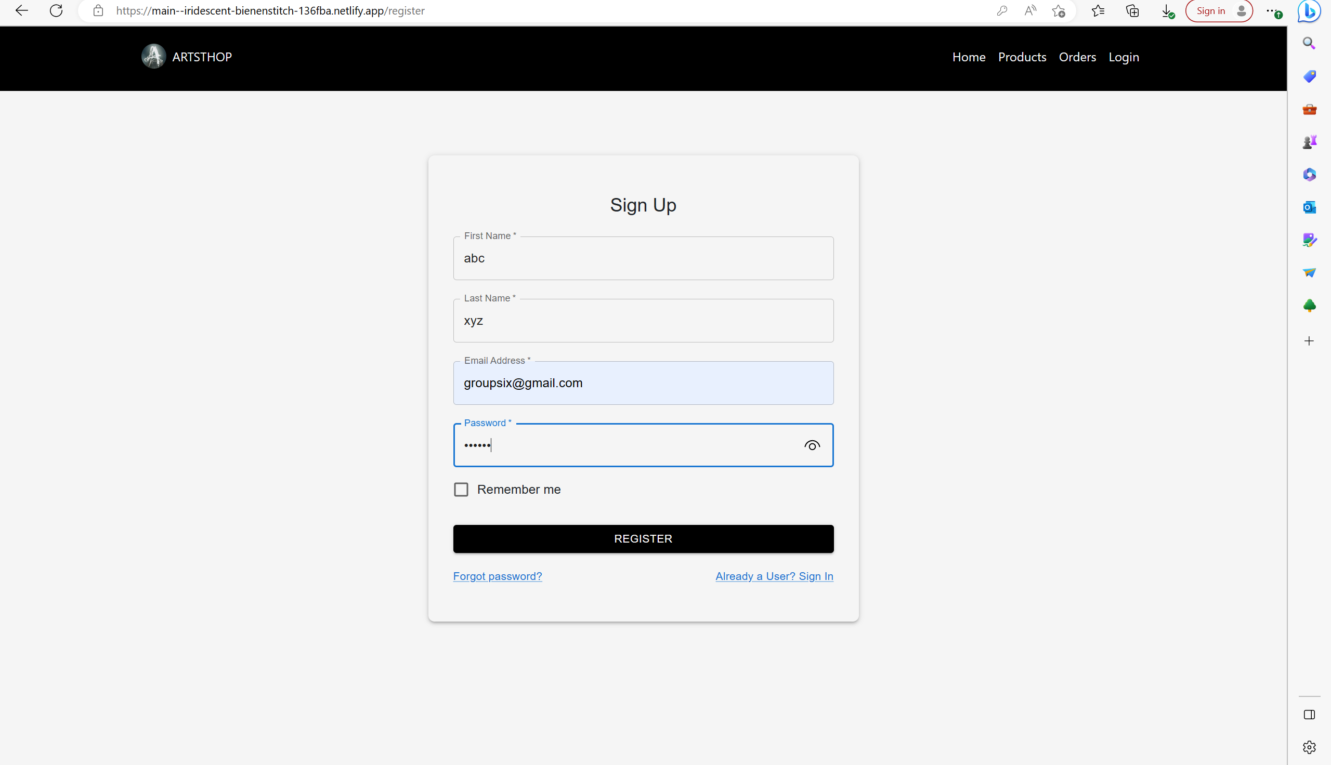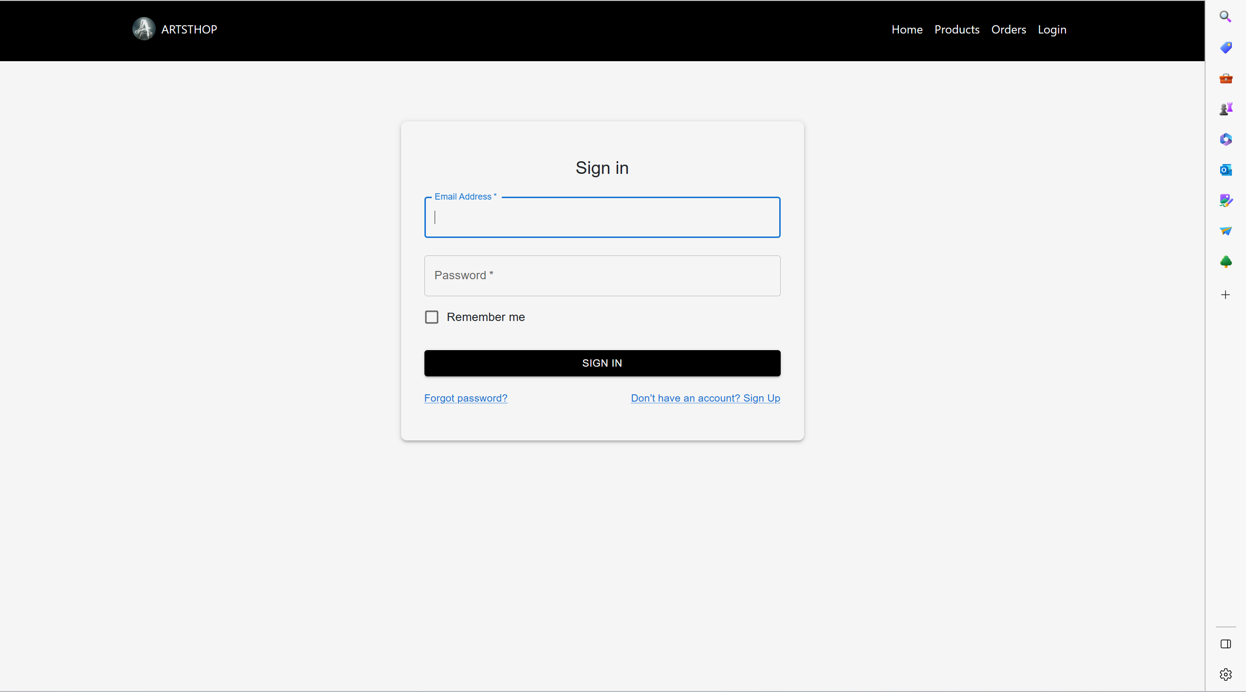 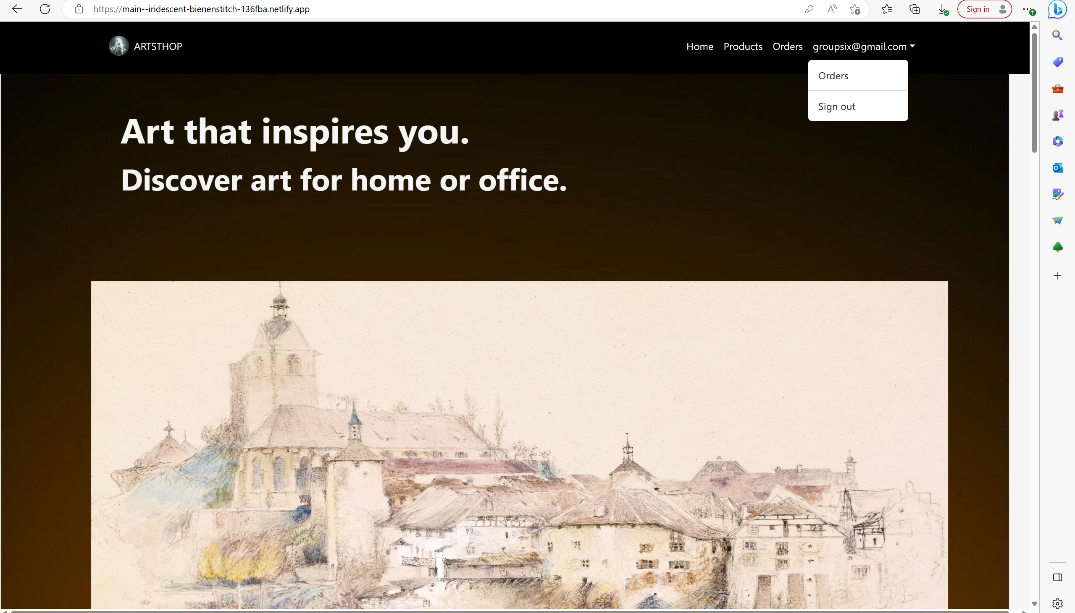

**Technology and deployment:**

*Front-end:* React JS,

*Backend:* MongoDB, NodeJS, Express JS

*Testing*: Jest

*Deployment*: Netlify for front end, IBM cloud for backend

*Login*: Firebase for user auth login register

**Future improvements:** All the listed limitations can be used for future improvements and making the website more secure once we are able to test payments. We can use this website as a template for an artist in real time to host their website.

**References:**

[**https://stackblitz.com/edit/google-pay-react?file=src%2FApp.js**](https://stackblitz.com/edit/google-pay-react?file=src%2FApp.js)

[**https://stackblitz.com/edit/react-shopping-cart-2?file=src%2FApp.js**](https://stackblitz.com/edit/react-shopping-cart-2?file=src%2FApp.js)

**Examples uploaded on Brightspace.**